reliance matrix
A MEMBER OF THE TOKIO MARINE GROUP
Workforce Accommodations Data
2022–2025 Benchmark Analysis
A Trend Analysis for Workplace Accommodation Professionals
September 2026
Four full calendar years of transactional accommodation data (2022–2025) — 103,134 requests and 208,485 individual accommodations — analyzed alongside client headcount trends and the Integrated Benefits Institute's 2026 industry survey of ADA administration practices.

Executive Summary
Reliance Matrix's workforce accommodations book of business grew substantially between 2022 and 2025 — from 196 to 301 employer clients and from 778,056 to 993,334 average covered employees — and accommodation activity grew faster still. This analysis looks past the topline volume increase to the underlying trends employers, providers and consultants will want to understand: where incidence is rising fastest, how legal basis and accommodation type are shifting, what drives outcome and duration, and how client and industry composition are changing shape within the book itself.
Findings here are triangulated wherever possible against the Integrated Benefits Institute’s 2026 survey of HR decision-makers on ADA administration practices, cited throughout as "IBI (2026)" — an external benchmark for how this book’s experience compares to the broader market.

Key Findings
- Incidence climbed from 2.293 per 100 employees in 2022 to 3.157 in 2025 (+38%), and the increase is broad-based: 75.9% of individually tracked clients saw incidence rise over the period, not a small number of large accounts.
- Legal basis is diversifying. Disability (ADA) requests fell from 100% of typed volume in 2022 to 89.5% in 2025 as Pregnancy (PWFA) requests grew from negligible to 3,120 events — a direct, traceable effect of the PWFA's June 2023 effective date.
- Leave remains dominant (61% of 2025 accommodations) but duration is stretching across nearly every non-leave type — Equipment (+73%), Changes to the Workplace (+101%), and Break Modification (+64%) all lengthened materially from 2022 to 2025, while pure Leave held flat (46 → 47 days).
- Decision speed correlates directly with outcome: accommodations decided within 14 days are approved 85.9% of the time, falling to 67.2% beyond 60 days, and average duration nearly doubles across the same split (86.4 to 131.8 days). Median time-to-decide is 7 days; 83.2% of decisions land within 30 days, well ahead of IBI (2026)'s industry benchmark of 75.1%.
- Recidivism is concentrated: 81.9% of requesting employees file only once, but the 18.1% who return account for 34.6% of all events — a case-management population worth identifying early.
- Female utilization is 2.54× male utilization in 2025, but strips down to 2.2× once pregnancy-related requests are excluded — a materially different picture of the underlying gender pattern.
- Industry representation varies more than twofold at the 2-digit SIC level: Insurance Agents/Brokers/Service files accommodations at 2.19× its headcount share, while Apparel and Accessory Stores files at roughly one-fifth of its headcount share.
- The book's industry composition shifted alongside its growth: Health Services rose from 11.47% to 19.28% of covered headcount, while several single-client exits and additions materially reshaped other industries' shares — a reminder that book-of-business composition, not just accommodation behavior, is fluid.
- Median earnings among accommodation filers is $51,106, concentrated in the $30k–$50k band (37.8% of salaried events); newer employees are disproportionately represented (51.9% have under 3 years' tenure).

Section 1 — Prime Drivers of Accommodation Incidence
An "Event" is a single accommodation request (case); an "Accommodation" is a specific type of accommodation associated with that case. A case can involve more than one accommodation type. For example, a single event may be filed with a basis of pregnancy, and this pregnancy event may have associated accommodations of intermittent leave as well as additional breaks granted within it. Incidence is expressed per 100 covered employees using average annual headcount as the denominator.
Year | Events (cases) | Accommodations (items) | Avg. Population | Incidence / 100 Employees
2022 | 17,839 | 36,827 | 778,056 | 2.293
2023 | 22,435 | 47,155 | 887,741 | 2.527
2024 | 31,500 | 63,038 | 1,102,633 | 2.857
2025 | 31,360 | 61,465 | 993,334 | 3.157
Incidence has climbed steadily across all four years, from 2.293 to 3.157 per 100 employees — a 38% increase. The number of distinct accommodations per case has eased slightly, from 2.064 in 2022 to 1.96 in 2025, suggesting cases are being resolved with a somewhat narrower set of accommodation types even as overall volume grows. Section 8 decomposes this trend further by client and industry.
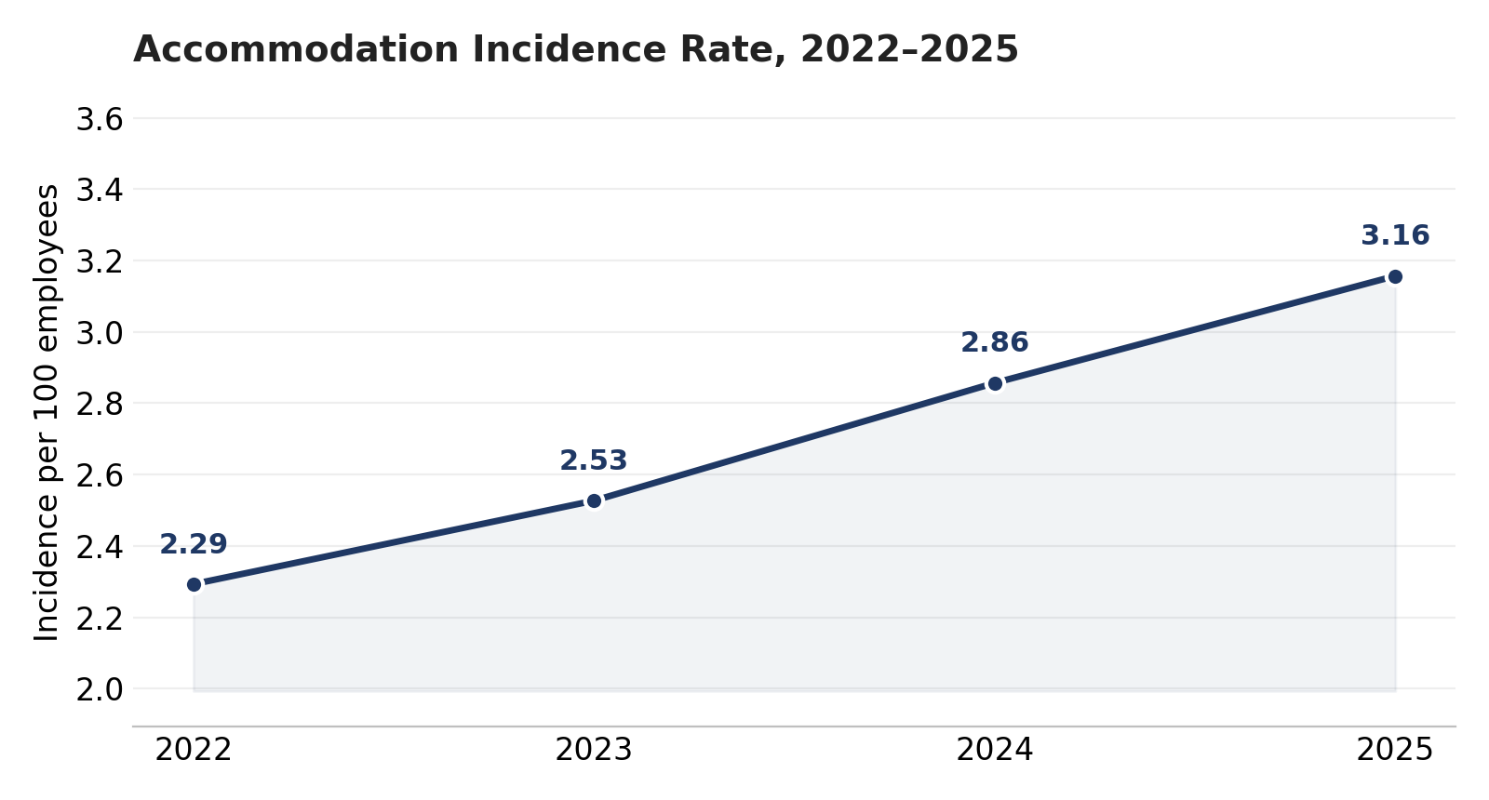
Figure 1. Accommodation incidence per 100 employees, 2022–2025.

Is the 2025 Increase Legislative or Eligibility-Driven?
The period covers two clear legislative developments: the Pregnant Workers Fairness Act's (PWFA) effective date of June 27, 2023, and a wave of state-level accommodation-mandate expansions that first appear in this book's data in 2023. Both plausibly inflate incidence independent of any underlying change in workplace need, so the increase should not be presented without asking how much of it they explain. Decomposing the 0.86-point rise in incidence per 100 employees from 2022 to 2025 by legal basis: 36.3% of the increase is attributable to growth in Pregnancy (PWFA) accommodations, 61.9% to continued growth in Disability (ADA) accommodations, and the remaining 1.8% to Religious and state-law accommodations.
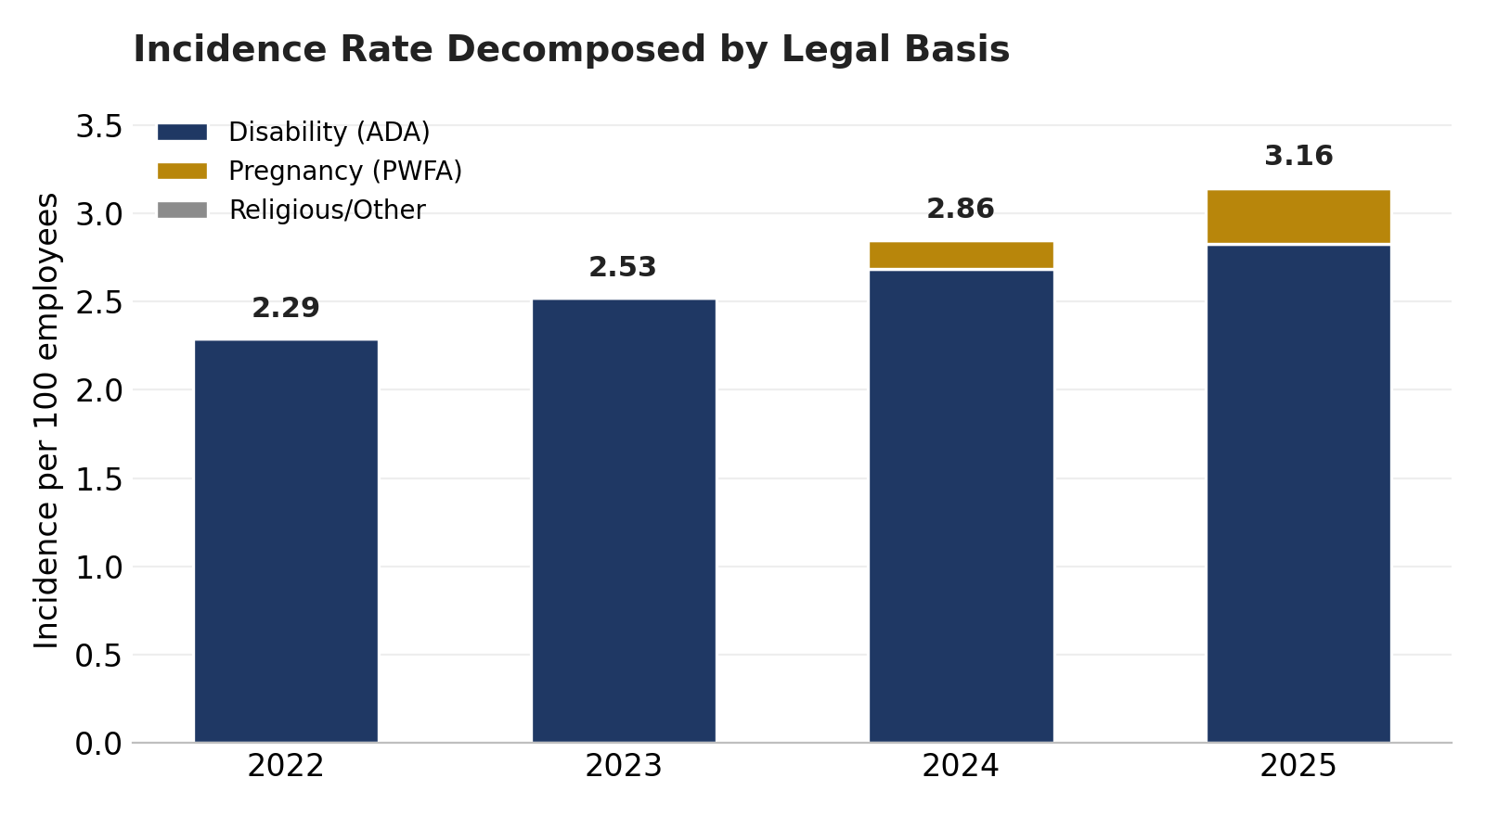
Figure 2. Incidence rate decomposed by legal basis, 2022–2025.
In short: PWFA eligibility expansion is a real and material contributor — explaining a little over a third of the total increase — but it is not the primary driver. The larger share of the increase reflects rising utilization of the pre-existing ADA disability-accommodation process itself, which points toward factors such as book-of-business industry mix shift (Section 8), growing employee and employer awareness of the accommodation process, or administrative changes in how requests are captured, rather than the PWFA alone. Looking only at the most recent year-over-year move (2024 to 2025, +0.30 points), the same pattern holds: 50.5% of that specific increase traces to PWFA growth and 47.0% to continued ADA growth, so the legislative effect is not concentrated in the most recent year — it has been a steady, gradual contributor since mid-2023 rather than a one-time step change.
State-law accommodation categories (item-level "Category" tag) grew from 221 items in 2023 to 1,251 in 2025, corroborating a broader — if smaller — legislative contribution beyond the PWFA; this tag is sparsely populated for 2022 (see Section 2 note) so is used here only as directional, not quantitative, support.

Section 2 — Accommodation Category & Type

By Legal Basis (Event Level)
The request-reason field provides a clear picture of how the mix of legal drivers has shifted:
Year | Total Events | Disability (ADA) | Pregnancy (PWFA) | Religious | Other
2022 | 17,839 | 17,834 | 1 | 4 | 0
2023 | 22,433 | 22,404 | 6 | 19 | 4
2024 | 31,500 | 29,613 | 1,794 | 87 | 6
2025 | 31,360 | 28,077 | 3,120 | 148 | 15
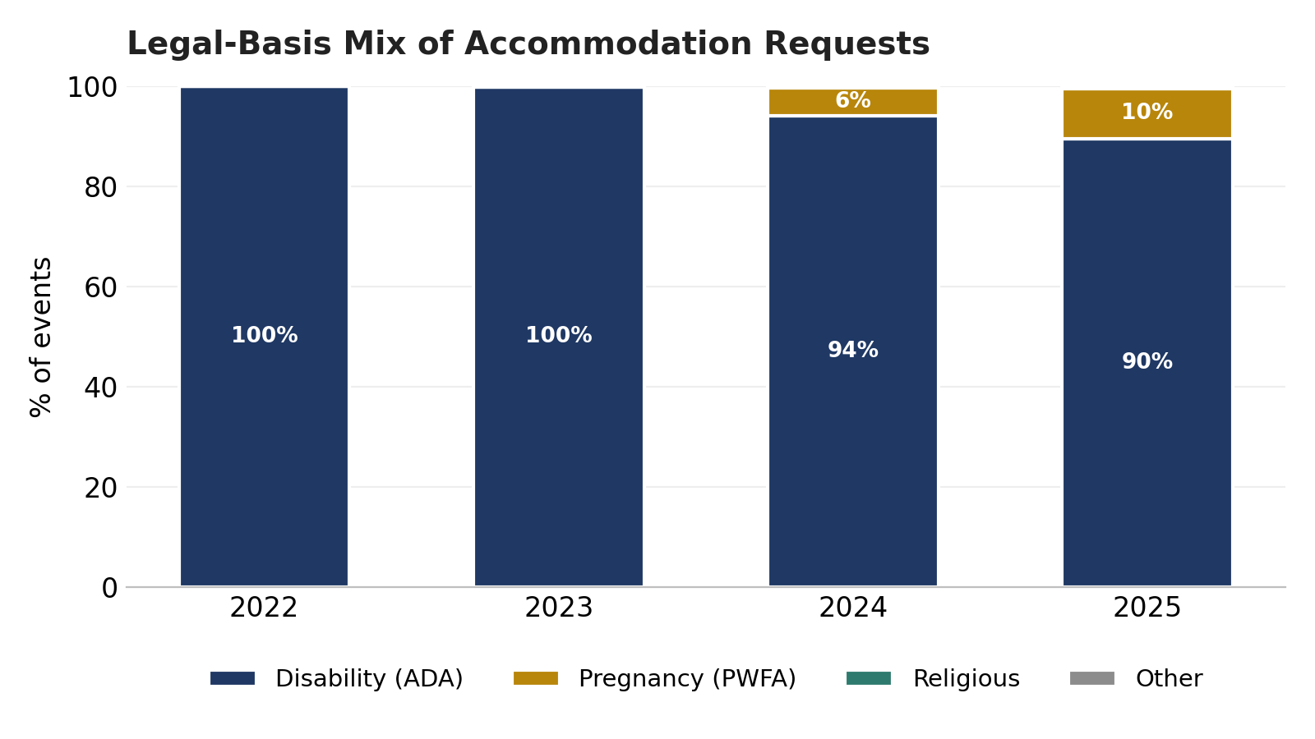
Figure 3. Legal-basis mix of accommodation requests by year.
Pregnancy-related requests were effectively nonexistent in 2022 (1 events) and 2023 (6 events), then rose sharply to 1,794 in 2024 and 3,120 in 2025 — tracking the Pregnant Workers Fairness Act's effective date of June 27, 2023, and the subsequent ramp in employer awareness and utilization. Religious accommodation requests remain a small but growing share, from 4 events in 2022 to 148 in 2025.

By Accommodation Type (Item Level)
Across 208,485 individual accommodations granted 2022–2025, Leave (as an Accommodation) is the single largest category at 49.0% of volume, followed by Physical (12.9%), Work at Home (12.3%), and Intermittent Leave (9.7%). All leave-type accommodations (Leave + Intermittent Leave) combined represent 61% of 2025 volume, consistent with the 55–61% range seen across all four years.
Accommodation Type | % of All (2022–25) | % of 2022 | % of 2025
Leave as an Accommodation | 49.0% | 50.2% | 50.6%
Physical | 12.9% | 14.9% | 10.8%
Work at home | 12.3% | 10.0% | 10.6%
Intermittent Leave | 9.7% | 9.3% | 10.4%
Modified work schedule | 5.7% | 6.5% | 5.5%
Break Modification | 4.2% | 2.8% | 5.1%
Job restructuring | 1.6% | 1.6% | 1.8%
Equipment | 1.3% | 1.1% | 1.4%
Other | 1.0% | 1.1% | 1.2%
Changes to the workplace | 1.0% | 0.8% | 1.0%
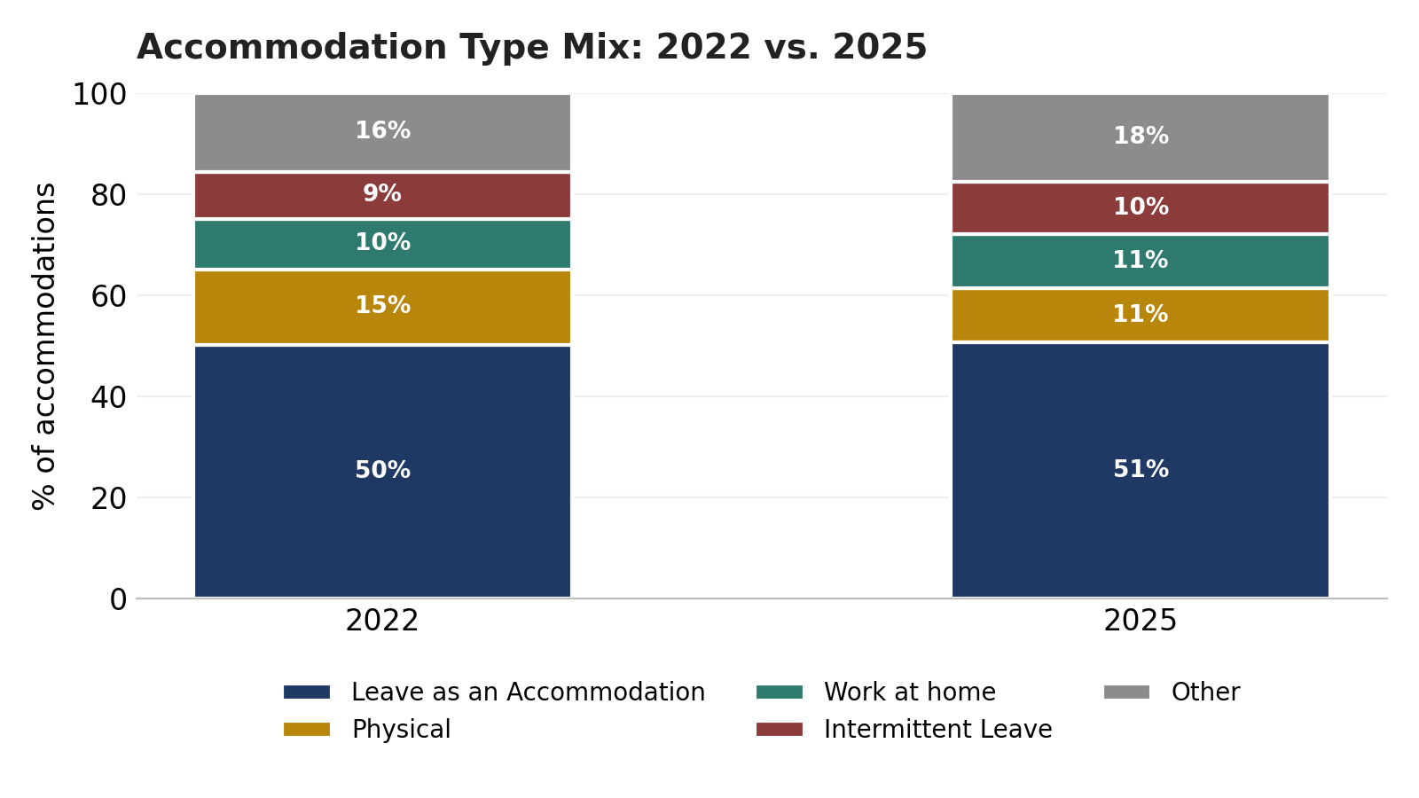
Figure 4. Accommodation type mix, 2022 vs. 2025.

Requested vs. Approved Mix
The type mix above describes accommodations that were granted; it is a different question whether the mix of what employees ask for matches the mix of what gets approved. Comparing the type composition of all requested items against the type composition of approved items only shows where approval rates skew the two apart:
Accommodation Type | Requested % | Approved % | Δ (pts)
Leave as an Accommodation | 49.0% | 54.5% | +5.5
Physical | 12.9% | 11.2% | -1.6
Work at home | 12.3% | 11.7% | -0.6
Intermittent Leave | 9.7% | 8.3% | -1.4
Modified work schedule | 5.7% | 5.1% | -0.6
Break Modification | 4.2% | 3.8% | -0.5
Job restructuring | 1.6% | 1.1% | -0.5
Equipment | 1.3% | 1.3% | +0.0
Other | 1.0% | 0.8% | -0.2
Changes to the workplace | 1.0% | 0.8% | -0.1
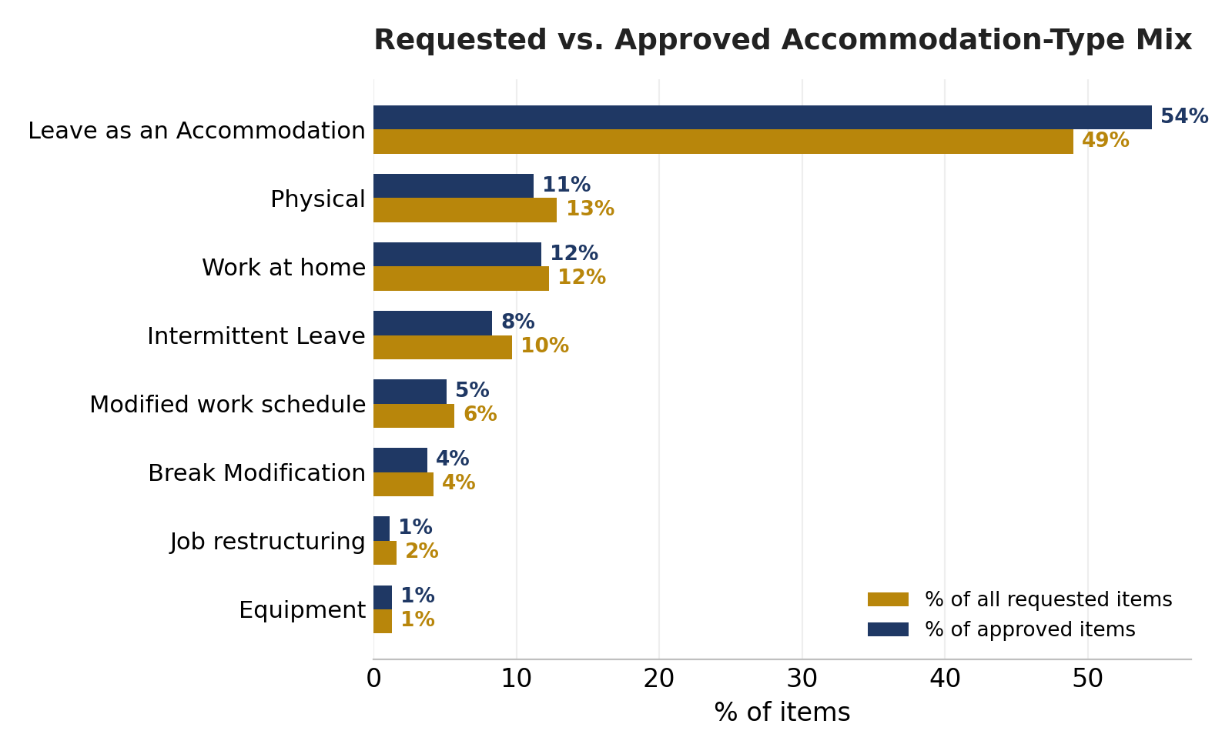
Figure 5. Requested vs. approved accommodation-type mix, all years combined.
Leave (as an Accommodation) is both the most-requested type and further over-represented among approvals (49.0% requested vs. 54.5% approved) — consistent with its 89.2% approval rate, well above the book-wide average of 80.2%. Physical and Intermittent Leave move in the opposite direction, each a smaller share of approvals than of requests, indicating below-average approval rates for those types specifically rather than simply lower request volume.

Requested vs. Approved Mix, by Industry
The book-wide pattern is not uniform across industries. Among 2-digit SIC groups with meaningful volume (at least two contributing clients), overall approval rates range from 68.1% to 89.6%, and the dominant accommodation type requested is not always Leave:
Industry (2-Digit SIC) | Clients | Top Type | Top Type % | Top Type Appr. | Overall Appr.
Health Services | 43 | Leave as an Accommodation | 60.1% | 89.1% | 80.9%
Business Services | 60 | Leave as an Accommodation | 45.7% | 87.8% | 78.5%
Engineering, Accounting, Research & Management Services | 26 | Leave as an Accommodation | 36.9% | 90.6% | 79.8%
Depository Institutions | 13 | Leave as an Accommodation | 25.9% | 88.6% | 75.5%
Chemicals and Allied Products | 23 | Leave as an Accommodation | 56.2% | 92.2% | 81.8%
Measuring, Analyzing & Controlling Instruments; Medical/Optical Goods | 8 | Leave as an Accommodation | 50.9% | 88.1% | 82.0%
Wholesale Trade - Durable Goods | 18 | Leave as an Accommodation | 43.6% | 88.7% | 82.7%
Insurance Agents, Brokers, and Service | 8 | Leave as an Accommodation | 52.9% | 92.5% | 83.2%
Wholesale Trade - Nondurable Goods | 9 | Leave as an Accommodation | 51.6% | 88.8% | 80.2%
Transportation by Air | 5 | Leave as an Accommodation | 55.8% | 92.9% | 75.6%
Miscellaneous Retail | 7 | Physical | 36.1% | 80.2% | 82.5%
Transportation Equipment | 6 | Leave as an Accommodation | 38.3% | 87.2% | 76.0%
Table limited to 2-digit SIC groups with at least two contributing clients and at least 150 items over the period, sorted by item volume. "Top Type" is each industry's single most-requested accommodation type; its approval rate is shown alongside the industry's overall approval rate across all types.

Work-from-Home Trend, 2022–2025
Work-from-home accommodation volume does not follow the book's broader growth pattern. It peaked in 2023 at 8,040 requests, then declined for two consecutive years to 7,358 (2024) and 6,541 (2025) — a decline of 18.6%, or roughly one-fifth, from its 2023 peak — even as overall accommodation volume and incidence continued to climb every year of the period.
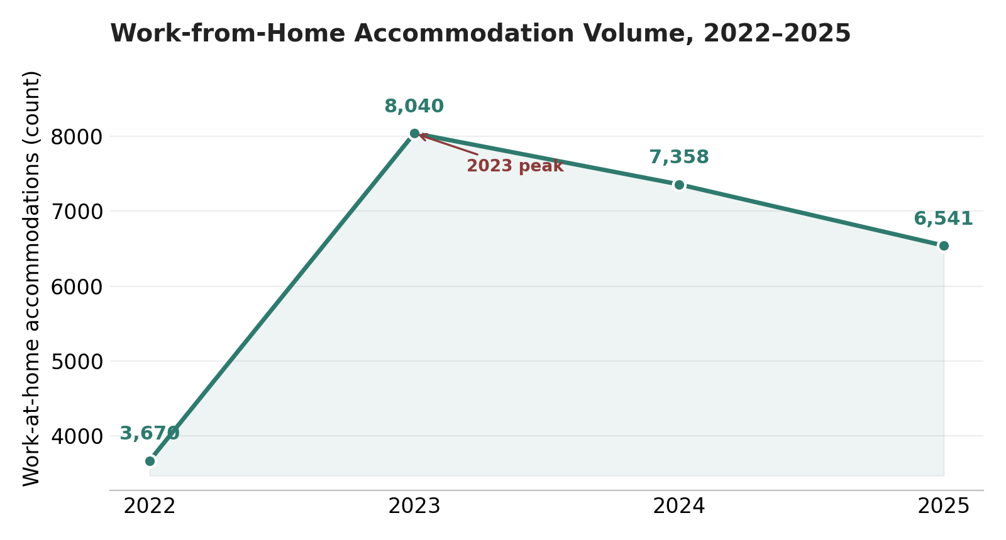
Figure 6. Work-from-home accommodation volume, 2022–2025.
Several plausible, non-exclusive explanations could account for this reversal, and this data cannot adjudicate among them: the broader post-pandemic normalization of remote work as a standard job feature rather than something formally requested as an ADA accommodation; employer-side return-to-office policies narrowing what is treated as an accommodation-eligible arrangement versus a standard work option; and improved interactive-process triage directing employees toward other stay-at-work accommodations instead — Modified Work Schedule and Break Modification volumes, by contrast, grew in every year of the period. This report does not have data on workforce composition changes such as outsourcing or offshoring of remote-eligible roles, and this trend should not be read as evidence of, or a case for, such a strategy; it is presented strictly as an accommodation-volume pattern for practitioners to weigh against their own workforce-planning context.

Section 3 — Duration & Stay-at-Work Outcomes
Leave and non-leave "stay-at-work" accommodations (work-at-home, modified schedule, break modification) behave differently enough that they are best read separately rather than as a single blended figure:
 | Avg. Duration (Days) | Temporary | Ongoing
Leave (incl. intermittent) | 68.3 | 99.6% | 0.4%
Non-leave stay-at-work* | 158.0 | 88.8% | 11.2%
*Non-leave stay-at-work = Work at Home, Modified Work Schedule, and Break Modification. "Ongoing" (formerly labeled "permanent") indicates no defined end date at time of grant, as distinct from a temporary accommodation with a scheduled review or expiration.
Leave is nearly always temporary by design (99.6%) and comparatively short (68 days on average). Non-leave stay-at-work accommodations run more than twice as long on average (158 days) and are far more likely to be ongoing (11.2% vs. 0.4% for leave) — consistent with leave being governed by fixed statutory or medical timelines, while workplace-based accommodations are more often established as a standing arrangement.

Duration by Accommodation Type
Accommodation Type | Avg. Days (2022) | Avg. Days (2025) | Avg. Days (Overall)
Leave as an Accommodation | 46 | 47 | 47
Physical | 63 | 81 | 74
Work at home | 151 | 152 | 164
Intermittent Leave | 153 | 184 | 175
Modified work schedule | 85 | 145 | 120
Break Modification | 136 | 223 | 193
Job restructuring | 136 | 204 | 183
Equipment | 205 | 355 | 284
Other | 161 | 213 | 191
Changes to the workplace | 135 | 271 | 224
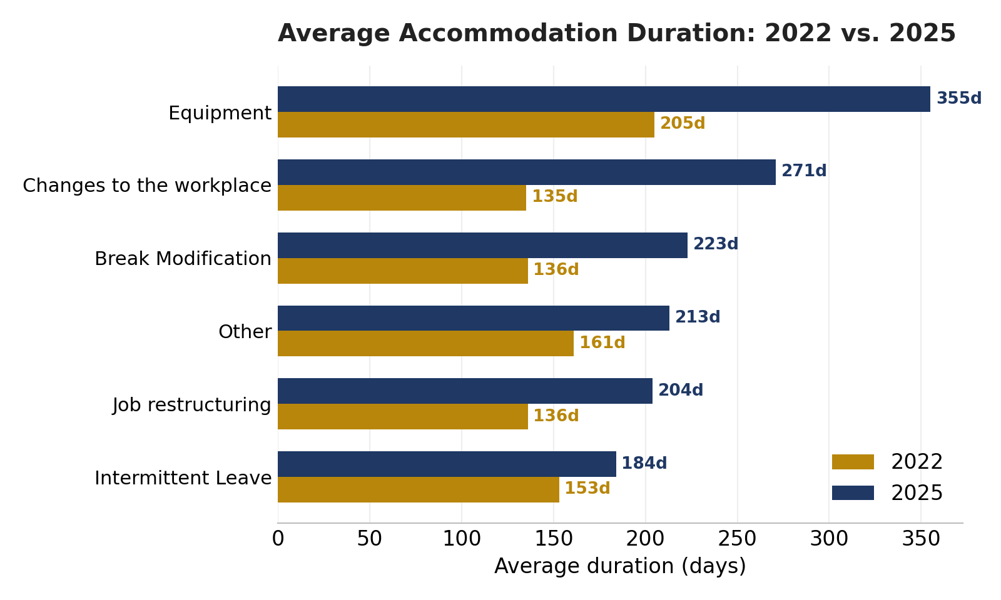
Figure 7. Average accommodation duration by type, 2022 vs. 2025 (types with the largest overall duration shown).
Average durations have lengthened for most non-leave accommodation types between 2022 and 2025 (e.g., Break Modification: 136 → 223 days; Equipment: 205 → 355 days; Changes to the Workplace: 135 → 271 days), while pure Leave accommodations have stayed comparatively short and stable (46 → 47 days) — a widening gap between how leave and workplace-based accommodations are administered over time.

Event-Level Case Duration
The durations above describe a single accommodation item's own start-to-end period. A separate, complementary question is how long the case as a whole — from intake to closure, across every accommodation item within it — stays open. Using the case's creation date and its closure date (fill rate 75.2% across 2022–2025), median case duration is 75 days (mean 120; 90th percentile 283 days) — noticeably shorter than the multi-hundred-day averages reported above for individual non-leave items, since a case typically closes once its accommodation is established even though the accommodation itself may remain active on an ongoing basis.
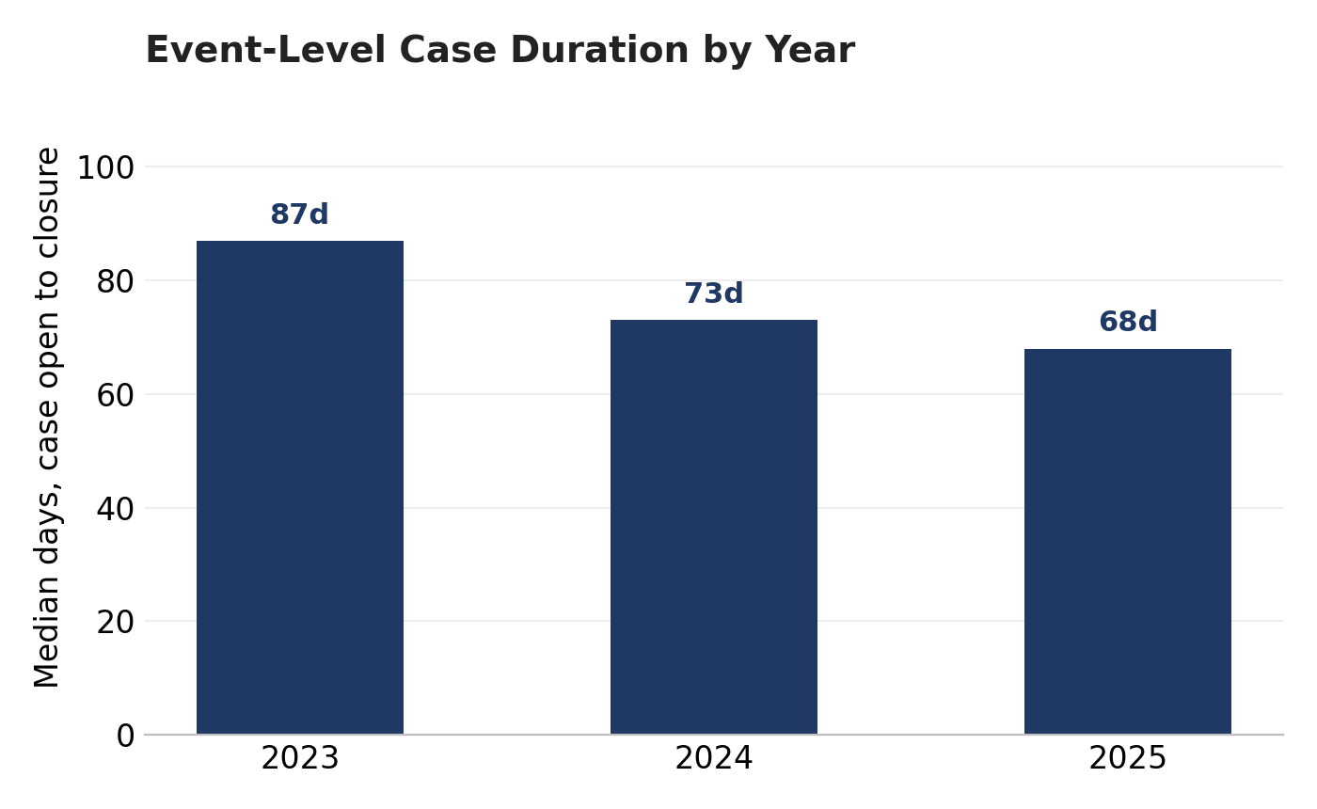
Figure 8. Median event-level case duration by year (2023–2025).
Case duration has shortened each year: median 87 days in 2023, 73 in 2024, and 68 in 2025 — consistent with the faster decision-making documented in Section 5. Cases built around a leave-type accommodation close modestly faster than other cases (median 70 vs. 87 days).
2022 is excluded from the year-by-year case-duration figures: the closure-date field was populated for only 6.7% of 2022 cases (vs. 76.9%–97.6% in 2023–2025), and the small set of 2022 cases with a closure date on file are disproportionately the longest-running, unresolved-at-the-time cases — including 2022 would materially overstate that year's typical case duration rather than reflect it.

Section 4 — Disability (ADA) vs. Pregnancy (PWFA)
Disability and Pregnancy-related requests differ enough in profile that blending them obscures both:
Measure | Disability (ADA) | Pregnancy (PWFA)
Total events, 2022–2025 | 97,928 | 4,921
Share of typed events | 95.0% | 4.8%
Accommodations per case | 2.04 | 1.6
Average duration (days) | 94.4 | 79.8
Approved | 80.0% | 85.4%
Denied | 11.4% | 5.7%
Pregnancy-related accommodations resolve faster on average (79.8 days vs. 94.4 days for Disability) and are approved more often (85.4% vs. 80.0%), consistent with PWFA cases typically involving well-defined, time-limited needs. Both groups lean heavily on Leave as the primary accommodation type (55.8% of Pregnancy accommodations vs. 48.8% of Disability accommodations), but Pregnancy cases skew further toward Leave and Break Modification and further away from Physical accommodations (9.3% vs. 13.0% for Disability).
Religious accommodations (259 events, 0.3% of the typed population) and vaccine-exemption requests (198 events total) are reported at summary level only — see Section 2 — as case volume remains too limited for a full side-by-side comparison.

Section 5 — Accommodation Outcomes

Approval Rate Trend
 | 2022 | 2023 | 2024 | 2025
Approved % (all events) | 82.0% | 81.0% | 80.1% | 78.5%
Approved % (ex. pregnancy) | 82.0% | 81.0% | 79.8% | 77.9%
The overall approval rate has eased from 82.0% in 2022 to 78.5% in 2025 — a modest decline even as request volume nearly doubled. Excluding pregnancy-related events (which approve at a materially higher rate) narrows the gap only slightly, indicating the broader decline is not simply a pregnancy-mix effect.

Outcomes Overall (2022–2025)
Outcome | 2022–2025 Count | % of Total
Accept | 167,145 | 80.2%
Denied | 23,284 | 11.2%
Rescind | 13,921 | 6.7%
Pending | 4,131 | 2.0%
"Pending" above is reported as of the extract date and combines three source-system statuses: the system's own "Pending" status, plus "More Discovery Needed" and "Schedule Interaction," which together account for 13.5% of this combined bucket (559 items). These are point-in-time snapshot counts of items still awaiting an outcome — not a count of interactive-process discussions that have taken place. This report does not have access to item-level status-history data (prior status transitions, or how many discovery or scheduling interactions occurred before the current snapshot was taken), so it cannot show how a given item moved through those interim stages, only that it currently sits, or at some point sat, in one. A "More Discovery Needed" or "Schedule Interaction" snapshot count should not be read as "N discovery conversations happened" — it is closer to "N items were awaiting further information or scheduling as of the extract."
Cases carrying an interim status while awaiting outcome tend to run longer than a typical accepted or denied item, consistent with unresolved documentation or scheduling being a genuine driver of case length rather than a rounding artifact.

Outcomes by Legal Category
Category | Accepted | Denied | Rescinded | Pending
ADA | 78.8% | 11.9% | 6.9% | 2.0%
PWFA | 85.6% | 5.4% | 7.3% | 1.5%
State | 86.2% | 7.1% | 5.1% | 1.4%
Religious | 62.0% | 20.5% | 14.4% | 1.1%
Religious accommodation requests see the lowest approval rate (62.0%) and the highest denial (20.5%) and rescission (14.4%) rates of any category — though on a small base (361 items). PWFA and State-equivalent requests are approved at the highest rates (85.6% and 86.2%, respectively).

Denied, But Not Necessarily Unresolved
Looking at each case (rather than each individual accommodation within it), 17,769 cases, 2022–2025, had at least one accommodation denied. Of those, 12,957 — 72.9% — also had a different accommodation accepted on the same case. A "Denied" outcome at the item level frequently is not the final word on the case.

Negotiated Outcomes: Sequential vs. Simultaneous
That 72.9% figure blends two materially different scenarios: an employee requesting several accommodation types together at intake (one later denied, another accepted — not really a negotiation at all), versus a denial genuinely followed by a negotiated alternative. Item-level creation dates let us sequence the two for the 12,957 qualifying cases with complete date data: in 50.8% of them, the accepted alternative was created strictly after the originally denied item (a median of 12 days later) — consistent with a genuine negotiated substitution. In the remaining 49.2%, both items were created together, indicating a parallel multi-item request rather than a negotiation following a denial.
Restricting further to the subset where the denied item's decision-completion date is on file (12,237 cases), 36.2% of alternatives were created only after that denial decision was finalized — the strictest available evidence of true sequential negotiation, and a meaningfully more conservative figure than the headline 72.9% would suggest on its own.

Decision Speed vs. Outcome and Duration
Median time from request to decision is 7 days (mean 19.5; decision-date fill rate 88.6%). 83.2% of decisions are made within 30 days — well ahead of the 75.1% industry figure reported by IBI (2026) for organizations that track ADA decision timelines, and further still ahead of IBI's 36.7% figure for decisions made within 14 days specifically (Reliance Matrix: 68.1%).
Decision speed is not neutral with respect to outcome: cases decided quickly are approved at a materially higher rate, and cases that take longer to decide also run longer overall — a "slow to decide, slow to resolve" pattern rather than two independent phenomena.
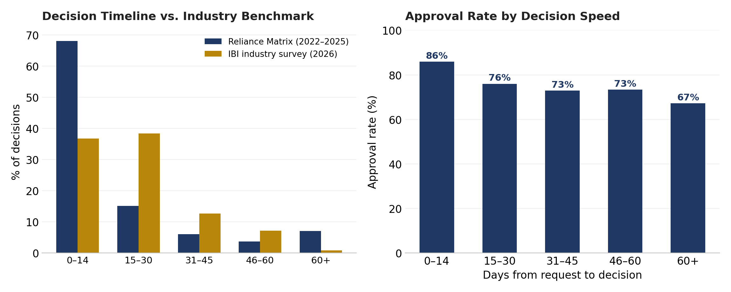
Figure 9. Decision timeline vs. IBI (2026) industry benchmark, and approval rate by decision speed.

Repeat Requestors
Among 82,106 employees who filed at least one accommodation request 2022–2025:
Requests per Employee, 2022–2025 | Employees | Share of Events
Exactly 1 | 81.9% | —
Exactly 2 | 13.6% | —
3 or more | 4.6% | —
All repeat requestors (2+) | 18.1% | 34.6%
Repeat requestors — employees with two or more accommodation events in the period — are a minority of the requesting population (18.1%) but account for a disproportionate 34.6% of all events. Identifying and proactively case-managing this population may offer a disproportionate return relative to its size.

Section 6 — Employer & Industry Profile
Across 301 employer clients and 34 distinct 2-digit SIC industry groups with meaningful volume, accommodation activity is not simply proportional to headcount. "Index" below is each industry's share of accommodation volume divided by its share of covered headcount — 1.00 means an industry files accommodations exactly in proportion to its size in the book; above 1.00 means over-represented relative to headcount, below means under-represented. Industry is reported at the 2-digit SIC major-group level throughout this report, and no individual client is identified.
Industry (2-Digit SIC) | Volume Share | Headcount Share | Index
80 — Health Services | 21.0% | 16.2% | 1.29
73 — Business Services | 12.2% | 16.1% | 0.76
87 — Engineering, Accounting, Research & Management Services | 7.7% | 5.3% | 1.44
60 — Depository Institutions | 7.3% | 5.7% | 1.28
28 — Chemicals and Allied Products | 6.7% | 4.4% | 1.52
38 — Measuring, Analyzing & Controlling Instruments; Medical/Optical Goods | 5.2% | 5.4% | 0.97
50 — Wholesale Trade - Durable Goods | 4.3% | 4.3% | 0.99
64 — Insurance Agents, Brokers, and Service | 4.2% | 1.9% | 2.19
51 — Wholesale Trade - Nondurable Goods | 3.0% | 2.6% | 1.14
45 — Transportation by Air | 2.6% | 2.2% | 1.19
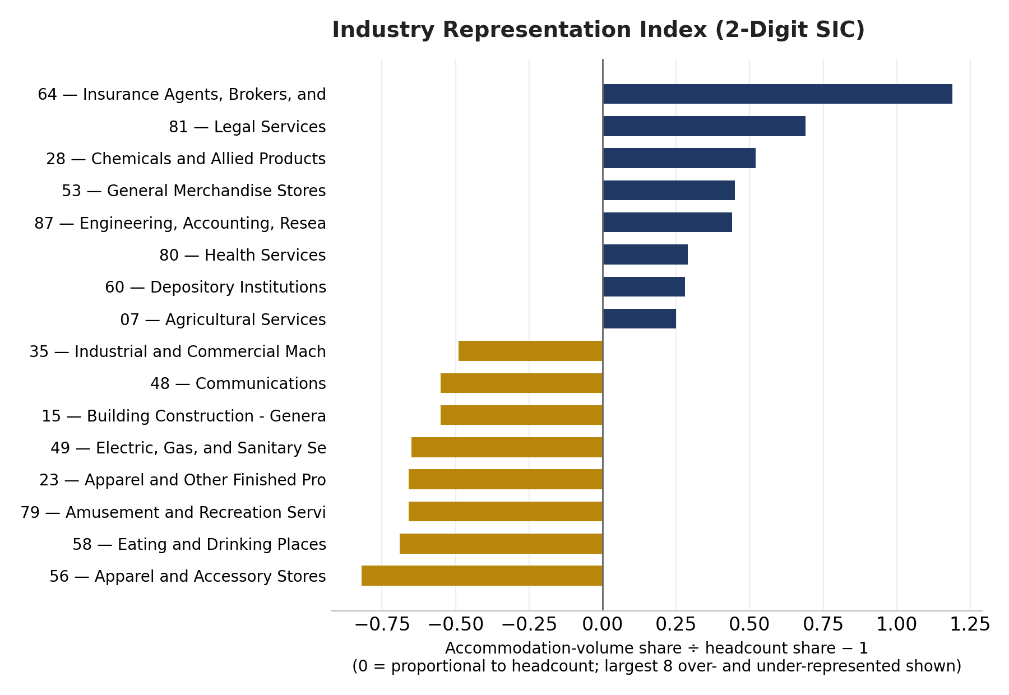
Figure 10. Industry representation index (2-digit SIC): accommodation-volume share vs. headcount share.
Insurance Agents/Brokers/Service, Legal Services, and Chemicals and Allied Products are the most over-represented industries relative to their headcount share; Apparel and Accessory Stores, Eating and Drinking Places, and Amusement and Recreation Services are the most under-represented. This pattern is broadly consistent with occupational and disability-exposure differences across industries rather than any single client’s experience — Section 8 examines how the book’s industry composition has shifted over the period.

Location
Accommodation volume by state largely tracks client population and headcount concentration, led by California, New York, Texas, Arizona, and Florida:
State | Accommodations | Rank
CA | 10,621 | #1
NY | 9,508 | #2
TX | 8,313 | #3
AZ | 7,896 | #4
FL | 6,095 | #5
IL | 5,381 | #6
NC | 5,109 | #7
WA | 3,457 | #8
PA | 3,445 | #9
GA | 3,292 | #10
OH | 3,077 | #11
TN | 2,692 | #12
MA | 2,470 | #13
NJ | 2,434 | #14
MN | 2,353 | #15

Section 7 — Demographic Drivers

Gender
Female employees continue to utilize accommodations at a substantially higher rate than male employees — 2.54 times as often in 2025, up from 2.34 times in 2022 (fill rate: 97.5% of events). excluding pregnancy-related events narrows the 2025 ratio to 2.2×, and — unlike the all-events ratio — this pregnancy-adjusted ratio has trended slightly downward since 2023 rather than up.
 | 2022 | 2023 | 2024 | 2025
Female | 12,082 | 15,320 | 21,808 | 22,083
Male | 5,166 | 6,345 | 8,978 | 8,736
F:M Ratio (all) | 2.34 | 2.41 | 2.44 | 2.54
F:M Ratio (ex. pregnancy) | 2.34 | 2.41 | 2.25 | 2.2
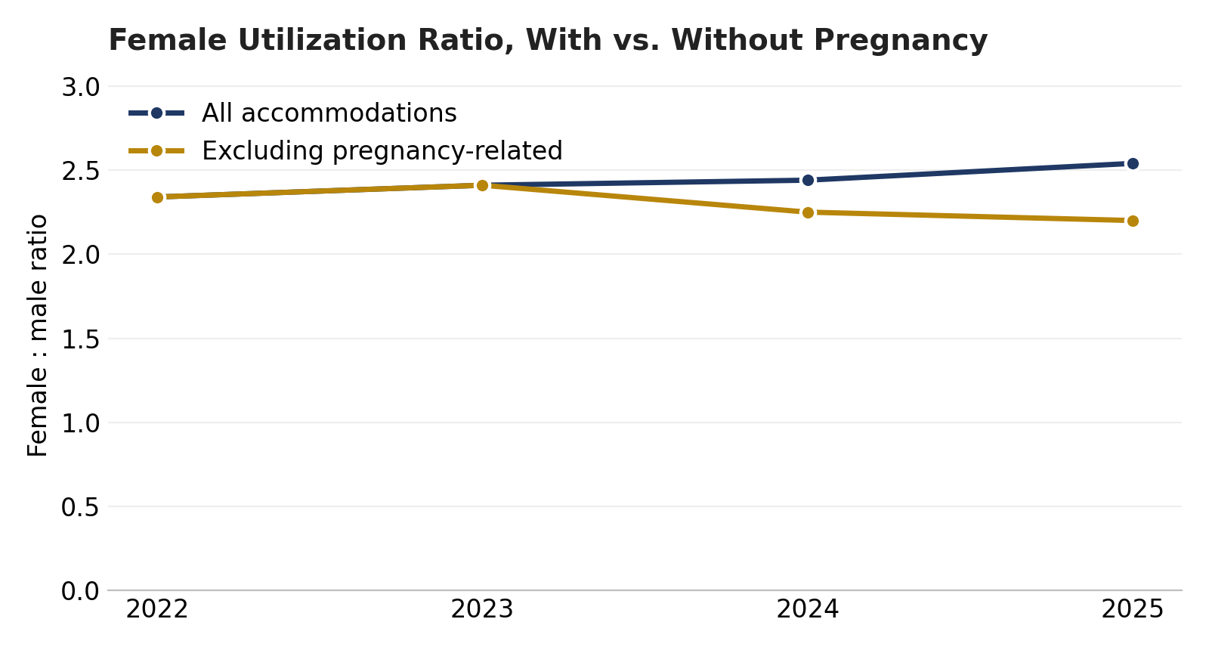
Figure 11. Female-to-male utilization ratio, with and without pregnancy-related requests.

Age
Median employee age at time of request is 42.2 years (fill rate: 98.7%). Volume is concentrated in the 30s through 50s, which together account for 68.4% of all requests.
Age Group | Events (2022–25) | % of Total
<20s | 663 | 0.7%
20s | 16,858 | 16.6%
30s | 28,172 | 27.7%
40s | 21,229 | 20.9%
50s | 20,279 | 19.9%
60s | 12,874 | 12.6%
70s+ | 1,726 | 1.7%

Tenure
Median tenure at time of request is 2.8 years (fill rate: 98.1%). Employees with fewer than 3 years of service account for 51.9% of all accommodation requests — a reminder that accommodation need is not concentrated among long-tenured staff.
Tenure | Events (2022–25) | % of Total
<1 yr | 29,989 | 29.7%
1-3 yrs | 22,489 | 22.2%
3-5 yrs | 12,927 | 12.8%
5-10 yrs | 16,464 | 16.3%
10-15 yrs | 6,635 | 6.6%
15+ yrs | 12,625 | 12.5%
Age and tenure above are reported as a share of accommodation requests, not indexed to the age/tenure distribution of the underlying covered population — the source extract captures demographics only for employees who have filed an accommodation request, not the full active workforce, so an incidence-style "requests per 100 employees of a given age or tenure band" cannot be computed from this data. A future edition could support that cut with a full active-population demographic extract.

Salary
Annual earnings are populated for 75.4% of events (excluding employees with no earnings on file); median earnings at time of request is $51,106. Consistent with the prior edition, utilization is concentrated in the $30k–$50k band:
Salary Band | Events (2022–25) | % of Salaried Events
<$20k | 4,964 | 6.4%
$20k-$30k | 2,980 | 3.8%
$30k-$50k | 29,376 | 37.8%
$50k-$75k | 19,120 | 24.6%
$75k-$100k | 8,347 | 10.7%
>$100k | 12,987 | 16.7%
Median earnings among accommodation filers are somewhat higher for males ($54,579) than females ($50,170), even though female employees file the large majority of requests overall (see Gender, above).

Section 8 — Client-Level Incidence Trends & Book-of-Business Composition
This section looks at how accommodation incidence trends at the individual client level, and how the industry composition of the book of business has shifted over the analysis period. No client is identified by name anywhere in this report; findings are presented as anonymized distributions or rolled up to the 2-digit SIC industry level, with any industry cut representing fewer than two distinct clients suppressed.

Distribution of Client-Level Incidence
To keep client-level comparisons on an apples-to-apples basis, this analysis is limited to clients with (a) at least 200 average employees, (b) at least 15 total accommodation events across 2022–2025, and (c) a full 12 months of headcount data in both 2022 and 2025 — this excludes 86 client-years where a client entered or exited the book of business partway through the year, which would otherwise distort an annualized rate. This leaves 83 clients eligible for trend comparison, out of 301 active clients in 2025.
Among these 83 clients, incidence rose from 2022 to 2025 for 75.9% and fell for 21.7%, with a median change of +0.58 per 100 employees (median incidence: 1.69 in 2022 vs. 2.00 in 2025) — the book-wide increase seen in Section 1 is broad-based across individual clients, not concentrated in a handful of large accounts. The chart below shows the full distribution (10th–90th percentile) rather than any individual client's figures:
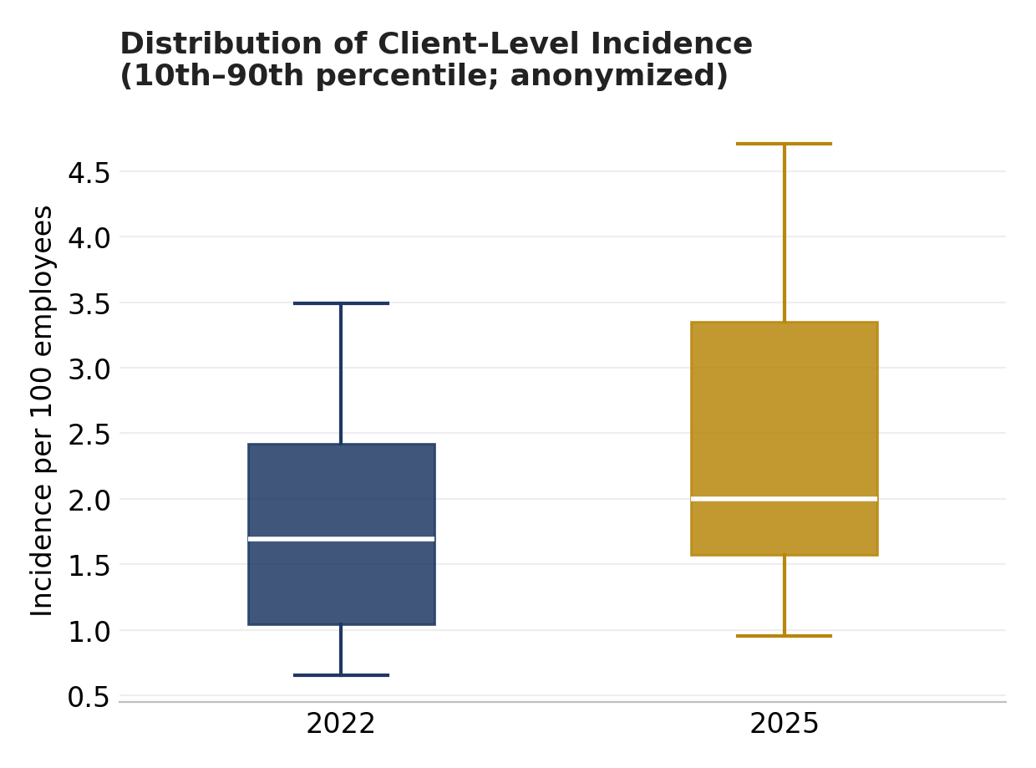
Figure 12. Distribution of client-level incidence, 2022 vs. 2025 (10th–90th percentile, anonymized).
Client-level incidence is sensitive to small base effects (a handful of additional cases at a mid-size client can swing the rate noticeably) and to plan design, claims-management practices, and workforce composition specific to that employer; these figures describe observed experience and are not intended as predictive of any individual client’s future incidence.

Incidence Trend by Industry (2-Digit SIC)
Rolling the same eligible clients up to their 2-digit SIC major group (industries with fewer than two contributing clients are omitted) shows where the book-wide incidence increase is concentrated:
Industry (2-Digit SIC) | Clients | 2022 | 2023 | 2024 | 2025
80 — Health Services | 10 | 3.55 | 3.75 | 4.01 | 4.33
38 — Measuring, Analyzing & Controlling Instruments; Medical/Optical Goods | 3 | 2.20 | 2.58 | 2.54 | 2.93
73 — Business Services | 8 | 3.10 | 2.90 | 3.89 | 4.51
59 — Miscellaneous Retail | 5 | 2.82 | 2.22 | 2.13 | 2.66
28 — Chemicals and Allied Products | 5 | 2.14 | 2.31 | 2.12 | 2.32
51 — Wholesale Trade - Nondurable Goods | 2 | 1.89 | 1.74 | 2.04 | 2.24
87 — Engineering, Accounting, Research & Management Services | 3 | 2.61 | 2.72 | 3.50 | 3.87
23 — Apparel and Other Finished Products | 2 | 0.68 | 0.88 | 0.91 | 1.37
20 — Food and Kindred Products | 3 | 3.08 | 2.80 | 3.68 | 3.75
60 — Depository Institutions | 3 | 2.41 | 2.28 | 2.44 | 2.72
65 — Real Estate | 2 | 1.83 | 1.55 | 1.78 | 2.12
82 — Educational Services | 2 | 2.02 | 1.75 | 2.32 | 3.18

SIC Mix of Client Headcount
The book of business grew from 196 clients in 2022 to 301 in 2025 (average headcount from 778,056 to 993,334), and this client turnover — new clients added, some clients departing — is a meaningful driver of how the industry mix of covered headcount has shifted, separate from any change in accommodation experience itself. Largest industries by 2025 headcount share:
Industry (2-Digit SIC) | 2022 Share | 2025 Share | Chg. (pts)
80 — Health Services | 11.5% | 19.3% | +7.8 pts
73 — Business Services | 21.6% | 9.3% | -12.3 pts
60 — Depository Institutions | 2.5% | 8.8% | +6.3 pts
38 — Measuring, Analyzing & Controlling Instruments; Medical/Optical Goods | 6.8% | 4.9% | -1.9 pts
51 — Wholesale Trade - Nondurable Goods | 1.0% | 4.4% | +3.3 pts
87 — Engineering, Accounting, Research & Management Services | 6.4% | 3.7% | -2.7 pts
28 — Chemicals and Allied Products | 5.5% | 3.4% | -2.1 pts
45 — Transportation by Air | 2.4% | 3.2% | +0.8 pts
50 — Wholesale Trade - Durable Goods | 4.3% | 3.1% | -1.1 pts
37 — Transportation Equipment | 0.6% | 3.0% | +2.4 pts
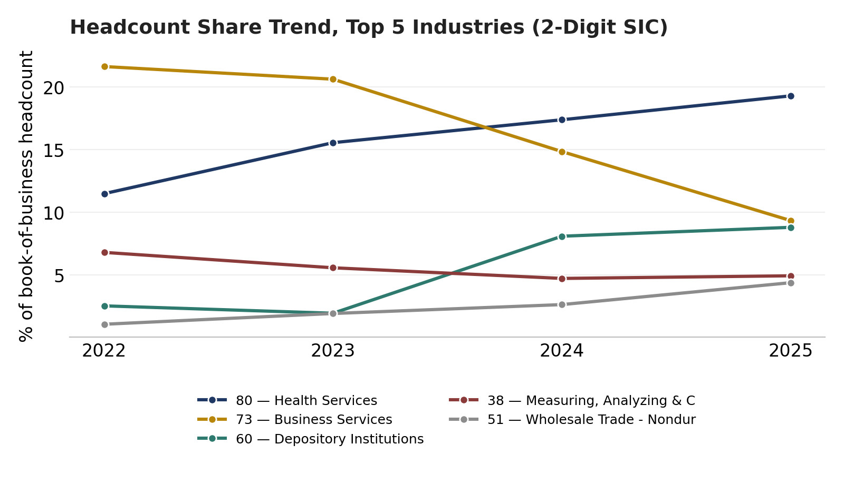
Figure 13. Headcount share trend, top 5 industries by 2025 share (2-digit SIC).

Largest Industry Mix Gainers and Losers
Beyond the largest single industries by share, the biggest point-change movers (2022 vs. 2025, among industries reaching at least 1% share in either year) show how concentrated these shifts are in a small number of client wins and departures rather than broad industry-level trends:
Industry (2-Digit SIC) | 2022 Share | 2025 Share | Chg. (pts)
80 — Health Services | 11.5% | 19.3% | +7.8 pts
60 — Depository Institutions | 2.5% | 8.8% | +6.3 pts
51 — Wholesale Trade - Nondurable Goods | 1.0% | 4.4% | +3.3 pts
37 — Transportation Equipment | 0.6% | 3.0% | +2.4 pts
70 — Hotels, Rooming Houses, Camps, and Other Lodging Places | 0.0% | 1.9% | +1.9 pts
Industry (2-Digit SIC) | 2022 Share | 2025 Share | Chg. (pts)
73 — Business Services | 21.6% | 9.3% | -12.3 pts
79 — Amusement and Recreation Services | 3.2% | 0.0% | -3.2 pts
87 — Engineering, Accounting, Research & Management Services | 6.4% | 3.7% | -2.7 pts
28 — Chemicals and Allied Products | 5.5% | 3.4% | -2.1 pts
38 — Measuring, Analyzing & Controlling Instruments; Medical/Optical Goods | 6.8% | 4.9% | -1.9 pts
The two largest gainers grew broadly rather than through one account: Health Services added contributing clients from 23 (2022) to 34 (2025), and Depository Institutions from 7 to 9. Business Services, the largest loser by far, nearly doubled its client count over the period (28 to 44) but still lost share — its collective headcount grew more slowly than the rest of the book, indicating a mix shift within a large, diverse industry rather than a single departure. Amusement and Recreation Services fell to a 0% share by 2025 because the small number of clients in that industry (three in 2022) had all exited the book by 2025.

Methodology & Data Notes

Data Sources
- Accommodation and Accommodation Item extracts, all non-deleted records created on or after January 1, 2022, joined on the accommodation record ID.
- Employee demographic extract (gender, birthdate, hire date, annual earnings, exempt/full-time flags), joined by employee number to the accommodation record.
- Client headcount-by-month extract and client/SIC industry mapping, joined by client account number and SIC code respectively, and used to compute incidence rates, industry representation, and book-of-business composition trends.
- Integrated Benefits Institute, "ADA Accommodation Practices in U.S. Workplaces" (May 2026), a 254-respondent survey of HR decision-makers, used for external benchmarking on decision-timeline practices — cited as "IBI (2026)" wherever referenced.

Definitions
- "Event": a single accommodation request/case (the Accommodation header record).
- "Accommodation" or "item": a specific type of accommodation associated with an event; a case may include more than one.
- Incidence per 100: events in a calendar year ÷ average monthly headcount for that year × 100.
- Duration: calendar days between an accommodation item’s start and end date, restricted to positive values under 10 years to exclude data-entry outliers. "Ongoing" indicates no defined end date at time of grant; "temporary" indicates a defined or expected end date.
- Decision lag: calendar days between an accommodation item’s creation date and its employer decision-completion date, restricted to 0–730 days.
- Industry representation index: an industry’s share of accommodation-item volume divided by its share of average covered headcount, both measured 2022–2025; 1.00 indicates volume proportional to headcount.
- Recidivism: an employee with two or more distinct accommodation events (not items) across 2022–2025.
- Case duration (event level): calendar days from a case's creation date to its closure date, covering the full case lifecycle across every accommodation item within it — distinct from item-level duration, which measures a single accommodation's own start/end period.
- Negotiated outcome: within a case that had at least one item denied, an alternate item later accepted whose creation date follows the denied item's creation date (and, where available, its decision-completion date) — as distinct from a case where both items were requested at the same time.

Anonymization & Industry Reporting Conventions
- This report identifies no individual employer client by name at any point, including in tables, chart labels, and narrative text.
- Industry is reported at the 2-digit SIC major-group level throughout (e.g., "80 — Health Services"), never at the 4-digit level, to keep findings at an industry-trend level of resolution rather than a level that could reasonably identify a specific client.
- Any industry-level cut representing fewer than 2 distinct clients is suppressed from client-level trend tables for the same reason (Section 8).

Known Data Limitations
- Annual earnings are provided by clients for 75.4% of events; records with zero or blank earnings are treated as missing rather than as a $0 salary band.

- A defensible blue-collar/white-collar occupational classification is not available in the source data and was not approximated.
- Demographic fields (gender, age, tenure) are captured only for employees who filed an accommodation request, not the full active workforce, so age- and tenure-based findings are reported as a share of requests rather than as an incidence rate against the covered population.
- Decision-completion date at the time of this study (point in time value) is populated for 88.6% of items; the decision-lag analysis (Section 5) is limited to that subset.

- Event-level case duration (closure date) is populated for 75.2% of cases 2022–2025, but unevenly by year — only 6.7% for 2022 vs. 76.9–97.6% for 2023–2025 — so 2022 is excluded from the year-by-year case-duration trend (Section 3) to avoid the strong selection bias in which 2022 cases happen to have a closure date on file.

References
Ghouralal, Sera-Leigh. ADA Accommodation Practices in U.S. Workplaces. Integrated Benefits Institute, May 2026.

Appendix — Detailed Year-by-Year Data
This appendix provides full four-year detail behind the summary tables and charts presented in the body of this report, for readers who want to trace a trend to its underlying annual figures.

A. Accommodation Type — Volume by Year
Accommodation Type | 2022 | 2023 | 2024 | 2025
Leave as an Accommodation | 18,490 | 22,029 | 30,505 | 31,096
Physical | 5,485 | 6,527 | 8,130 | 6,652
Work at home | 3,670 | 8,040 | 7,358 | 6,541
Intermittent Leave | 3,433 | 4,002 | 6,370 | 6,392
Modified work schedule | 2,392 | 2,479 | 3,550 | 3,399
Break Modification | 1,026 | 1,470 | 3,124 | 3,142
Job restructuring | 597 | 584 | 1,053 | 1,102
Equipment | 404 | 561 | 801 | 889
Other | 406 | 398 | 549 | 745
Changes to the workplace | 300 | 418 | 646 | 620

B. Accommodation Type — Average Duration (Days) by Year
Accommodation Type | 2022 | 2023 | 2024 | 2025
Leave as an Accommodation | 45.5d | 46.6d | 49.8d | 46.6d
Physical | 62.9d | 68.8d | 80.1d | 81.3d
Work at home | 151.4d | 176.9d | 167.6d | 151.7d
Intermittent Leave | 153.1d | 164.9d | 185.1d | 183.6d
Modified work schedule | 85.0d | 98.1d | 134.9d | 144.9d
Break Modification | 135.7d | 144.0d | 201.9d | 222.5d
Job restructuring | 136.5d | 146.6d | 200.8d | 203.5d
Equipment | 204.9d | 213.7d | 256.3d | 354.5d
Other | 161.1d | 148.2d | 208.0d | 212.6d
Changes to the workplace | 134.8d | 197.3d | 226.2d | 271.2d

C. Outcome — Volume by Year (All Categories)
"Pending" combines the system's own Pending status with the "More Discovery Needed" and "Schedule Interaction" interim statuses (see Section 5) — all three represent an item awaiting an outcome as of the extract date, not a count of completed interactive-process activity.
Outcome | 2022 | 2023 | 2024 | 2025
Accept | 30,184 | 38,204 | 50,499 | 48,258
Denied | 3,895 | 5,467 | 6,882 | 7,040
Rescind | 2,332 | 2,947 | 4,328 | 4,314
Pending | 416 | 537 | 1,327 | 1,851

D. Age Group — Event Volume by Year
Age Group | 2022 | 2023 | 2024 | 2025
<20s | 153 | 141 | 211 | 158
20s | 2,974 | 3,619 | 5,304 | 4,961
30s | 4,639 | 6,049 | 8,651 | 8,833
40s | 3,736 | 4,659 | 6,435 | 6,399
50s | 3,685 | 4,560 | 6,181 | 5,853
60s | 2,165 | 2,733 | 3,856 | 4,120
70s+ | 196 | 353 | 521 | 656

E. Tenure — Event Volume by Year
Tenure | 2022 | 2023 | 2024 | 2025
<1 yr | 6,465 | 6,850 | 8,821 | 7,853
1-3 yrs | 2,952 | 4,730 | 7,922 | 6,885
3-5 yrs | 2,131 | 2,496 | 3,553 | 4,747
5-10 yrs | 2,633 | 3,535 | 5,044 | 5,252
10-15 yrs | 1,098 | 1,380 | 1,865 | 2,292
15+ yrs | 2,087 | 2,931 | 3,754 | 3,853

F. Full Industry Representation Index (2-Digit SIC)
All 34 2-digit SIC industry groups with at least 0.5% share of either accommodation volume or headcount, sorted by representation index (accommodation-volume share ÷ headcount share).
Industry (2-Digit SIC) | Volume Share | Headcount Share | Index
64 — Insurance Agents, Brokers, and Service | 4.2% | 1.9% | 2.19
81 — Legal Services | 0.6% | 0.3% | 1.69
28 — Chemicals and Allied Products | 6.7% | 4.4% | 1.52
53 — General Merchandise Stores | 1.3% | 0.9% | 1.45
87 — Engineering, Accounting, Research & Management Services | 7.7% | 5.3% | 1.44
80 — Health Services | 21.0% | 16.2% | 1.29
60 — Depository Institutions | 7.3% | 5.7% | 1.28
07 — Agricultural Services | 1.7% | 1.4% | 1.25
57 — Home Furniture, Furnishings, and Equipment Stores | 1.1% | 0.9% | 1.23
45 — Transportation by Air | 2.6% | 2.2% | 1.19
51 — Wholesale Trade - Nondurable Goods | 3.0% | 2.6% | 1.14
47 — Transportation Services | 0.8% | 0.8% | 1.10
20 — Food and Kindred Products | 1.3% | 1.2% | 1.08
59 — Miscellaneous Retail | 2.6% | 2.4% | 1.08
50 — Wholesale Trade - Durable Goods | 4.3% | 4.3% | 0.99
37 — Transportation Equipment | 2.1% | 2.1% | 0.98
38 — Measuring, Analyzing & Controlling Instruments; Medical/Optical Goods | 5.2% | 5.4% | 0.97
67 — Holding and Other Investment Offices | 0.6% | 0.6% | 0.92
82 — Educational Services | 1.4% | 1.6% | 0.86
62 — Security and Commodity Brokers, Dealers, Exchanges & Services | 0.7% | 0.9% | 0.79
73 — Business Services | 12.2% | 16.1% | 0.76
70 — Hotels, Rooming Houses, Camps, and Other Lodging Places | 0.5% | 0.7% | 0.72
65 — Real Estate | 0.9% | 1.3% | 0.69
63 — Insurance Carriers | 1.8% | 2.7% | 0.69
36 — Electronic and Other Electrical Equipment | 1.2% | 1.8% | 0.67
55 — Automotive Dealers and Gasoline Service Stations | 0.4% | 0.7% | 0.58
35 — Industrial and Commercial Machinery & Computer Equipment | 0.8% | 1.6% | 0.51
15 — Building Construction - General Contractors | 0.4% | 0.8% | 0.45
48 — Communications | 0.3% | 0.6% | 0.45
49 — Electric, Gas, and Sanitary Services | 0.4% | 1.2% | 0.35
79 — Amusement and Recreation Services | 0.7% | 2.0% | 0.34
23 — Apparel and Other Finished Products | 0.8% | 2.3% | 0.34
58 — Eating and Drinking Places | 0.6% | 1.8% | 0.31
56 — Apparel and Accessory Stores | 0.2% | 0.8% | 0.18

